###### logo-leisurescapes

###### 

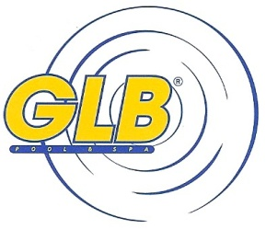

## Hot Tub Service/Repair

At Rintoul’s we offer Hot Tub service and repair for all makes and models. If you have a problem with your hot tub, let our professionals assess and repair the problem and have you relaxing and enjoying your hot tub in no time! Call, email or drop in to book a service call today. If you have technical questions relating to your Hot tub, please call the service department, and we can troubleshoot your problem for you.

Give us a call today at 519-376-5858, or send an email to service@rintouls.ca

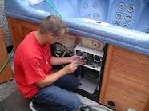

|  |  |  |
| --- | --- | --- |
|  | Owen Sound 689 10th St. W 519-376-5858 |  |